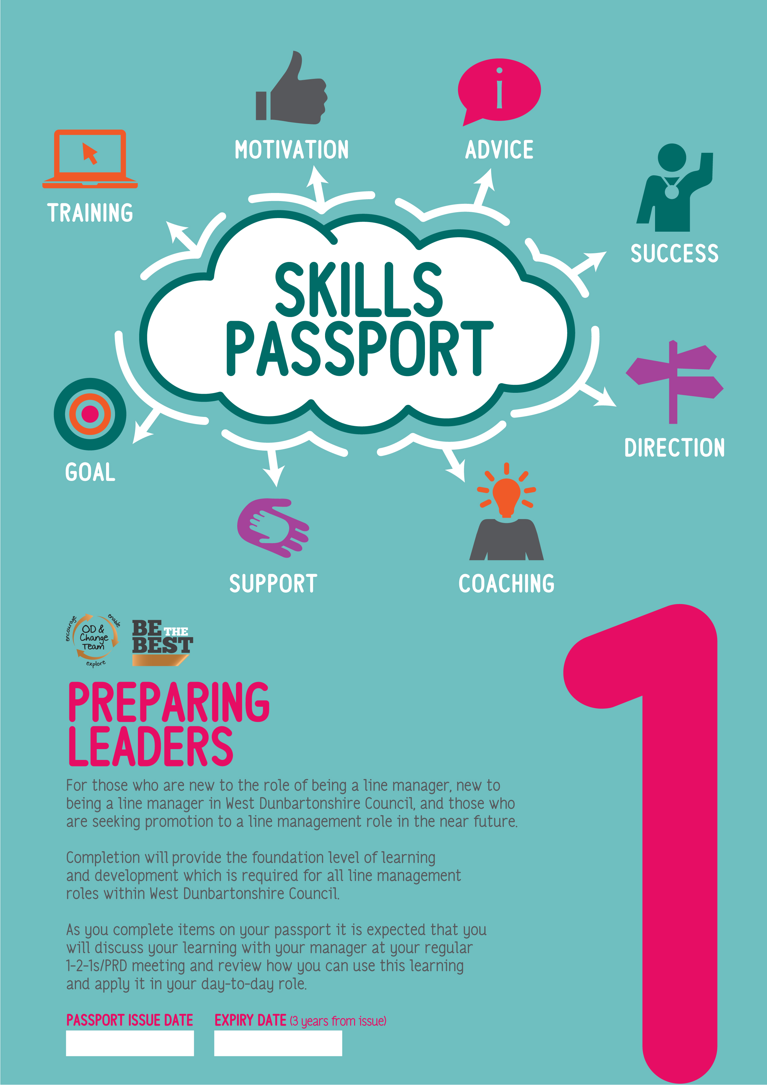

END DATE

20/07/2021

|  |  |  |
| --- | --- | --- |
| WORKSHOPS *(if not already completed)* | REFRESH | DATE COMPLETED |
| Be the Best at Managing People |  |  |
| New Managers Induction Programme |  |  |
| Risk Management |  |  |

|  |  |  |
| --- | --- | --- |
| READING | REFRESH | DATE COMPLETED |
| Be the Best |  |  |
| Code of Conduct |  |  |
| Health & Safety Partnership Agreement |  |  |
| Health & Safety – Policy Statement, Organisation and Arrangements |  |  |
| Relevant HR Policies and information |  |  |
| Relevant Risk, Health and Safety policies and information |  |  |
| Risk Management Framework |  |  |
| SWITCH (Redeployment) Policy |  |  |

|  |  |  |
| --- | --- | --- |
| E-LEARNING *(only if not previously completed and/or refresh is required)* | REFRESH | DATE COMPLETED |
| General E-Learning |  |  |
| ACHIEVE – Living the Values | Y – 3 years |  |
| Business Continuity Management |  |  |
| Citizen Charter |  |  |
| Climate Change and Sustainability |  |  |
| Data Protection Act 2018 and GDPR | Y – annually |  |
| Equality, Diversity and Human Rights | Y – annually |  |
| Equality Impact Assessment | Y – annually |  |
| Information Security | Y – 3 yrs |  |
| LGBTQ+ Awareness |  |  |
| People Management Framework |  |  |
| Procurement Awareness - *(for employees involved in the procurement process)* | Y – 2 yrs |  |
| Project Management Approach |  |  |
| Records Management | Y - 3 yrs |  |
| WDC Approach to Change |  |  |
| HR Policy & Procedure |  |  |
| Disciplinary Policy and Procedure |  |  |
| Supporting Employee Wellbeing Policy | Y - 3 yrs |  |
| WDC Recruitment & Selection |  |  |
| WDC Workplace Mediation |  |  |
| Risk, Health & Safety |  |  |
| Display Screen Equipment (DSE) Assessment | Y – 3 yrs |  |
| Fire Safety (Including Wardens) | Y – 2 yrs |  |
| Health and Safety Induction | Y – 3 yrs |  |
| Incident Reporting and Investigation | Y – 2 yrs |  |
| Ladder Safety Awareness *(role specific)* | Y – 2 yrs |  |
| Managing Safety | Y – 3 yrs |  |
| Manual Handling | Y – 3 yrs |  |
| Online Figtree Risk Assessment - Authorising | Y - annually |  |
| Responsible Premises Officer Guidance (RPO) *- only applies to those who are RPOs* | Y – 2 yrs |  |
| Risk Management | Y – 2 yrs |  |
| Slips, Trips and Falls | Y – 3 yrs |  |
| WDC Homeworking |  |  |

|  |  |  |
| --- | --- | --- |
| OPTIONAL LEARNING | METHOD | DATE COMPLETED |
| Coaching and Mentoring Excellence Scheme | 121 |  |

|  |  |
| --- | --- |
| **ADDITIONAL LOCAL LEARNING/CPD**  Use this space to record any additional learning and development | **DATE COMPLETED** |
|  |  |
|  |  |
|  |  |
|  |  |
|  |  |
|  |  |
|  |  |
|  |  |
|  |  |
|  |  |
|  |  |
|  |  |
|  |  |
|  |  |
|  |  |
|  |  |
|  |  |
|  |  |
|  |  |
|  |  |

**PLEASE NOTE:** Courses with **refresh** timelines indicate a **mandatory requirement** for employees to complete the resource and repeat as per the specified timeline. Completion data of mandatory courses is monitored.