
i-Learn: Frequently Asked Questions, Trouble Shooting & New Functionality

Frequently Asked Questions
Where do I find details of courses I have accessed or completed? | Log into WDC iLearn, select the learning history option from the front page – a list of the courses you have enrolled on or have completed will be displayed:
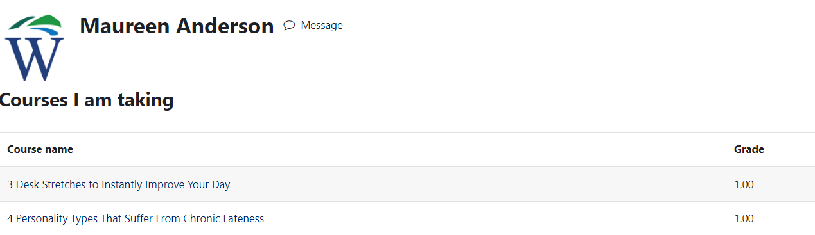
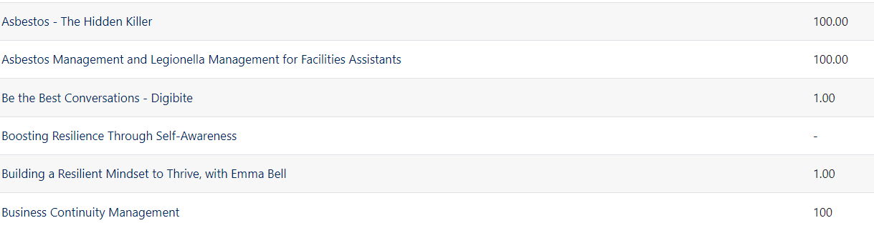
1.00 = complete
% score will record for courses requiring knowledge check completion
(-) = viewed or complete… depending on resource type

- Grade 1.00 = complete
- Grade (-) = course viewed or complete (depending on resource type e.g. link to URL)
- % mark achieved = for courses with a knowledge check requirement.

Depending on the type of course/resource – a grade may not be required to record a completed status.

My employee number is my username, I don’t know my employee number. | Your 7-digit employee number can be found on your payslip. Your line manager can also view your employee number on HR21.
I can't login to i-Learn. | If you have trouble logging in or if you have forgotten your password, select the ‘Lost password’ option on the login screen. This option will only work if the system has an up-to-date email address for you.  Alternatively, email: organisational.development@west-dunbarton.gov.uk
I am having trouble accessing i-Learn, my surname is MacDaid. | For surnames starting with, for example: McD or MacD or O’N, please capitalise the M and D; or the O and N.
I thought I had completed a course, but it is not showing as complete in my learning history course list.  Why does this happen? | This can be caused in various ways, the most common are:  - course window was closed before the course was 100% completed.  - network problems preventing data being saved.  - You have re-completed the course before the specified refresh timeline.  - Only the first date of completion will record on the system, no matter how many times you re-complete the course.  - You can view course completion activity (for courses completed after 19 April 2024) - see new functionality section of this document for details on how to do this.
What happens if I forget to log out of i-Learn? | You will be logged out automatically after 1 hour and your records will be saved.
- I don’t have access to a computer in my normal workplace so how can I access e-learn? | There are some options available to you:  - i-Learn is accessible 24/7 from your home PC or internet enabled device via the following URL: http://www.ilearn-wdc.co.uk.  - You can access i-Learn in your local library via the URL above.
Who should I contact if I need help? | If, after reviewing these FAQs, you need further assistance, please contact organisational.development@west-dunbarton.gov.uk
Troubleshooting

My computer has a popup blocker issue.  MS Edge version | Select the 3 dots at top right of MS edge, select settings, Cookies and site permissions – scroll down to Site permissions/pop-ups and redirects  Scroll to ‘Allow’, and then select Add: Type in the following URLs: https://wdcvle.westcollegescotland.ac.uk  http://www.ilearn-wdc.co.uk  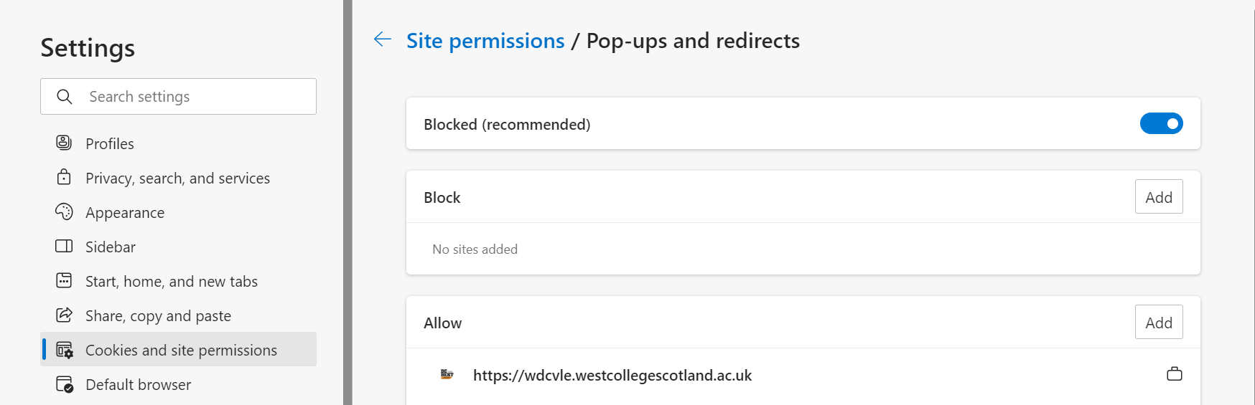
- What to do if error message ‘your screen resolution is too low’? | Change the screen resolution  - Select the Windows Button   - Select the settings cog   - Select system, then display, scroll down to resolution and select required size  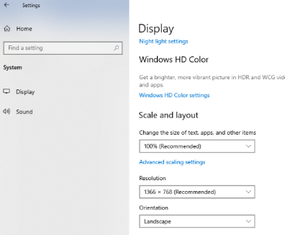  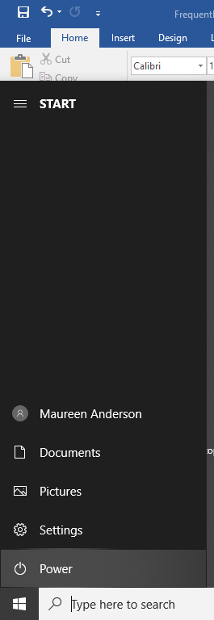
I can’t see any navigation buttons i.e. ‘Next’ and ‘Back’ | Select (…) on the toolbar to access the zoom option – adjust screen size as required.  

New functionality – available after platform upgrade and re-launch: April 2024
Please note:
The WDC iLearn Report Functionality is very limited. Here are a few things to keep in mind:

The learning management system will only log the first date of completion of a course/resource. The exception to this is when:

• A course is a corporate mandatory learning requirement and is re-completed in line with Skills Passport refresh timelines.

• A course has been updated and republished.

Courses which are not mandated across WDC will only log the first date of completion, no matter how many times they are completed by a learner. The exception to this is when:

• A course has been updated and republished.

We encourage learners to keep their Skills Passport up to date, by logging any additional completion dates as and when they complete/re-complete a resource.

NEW: How to view course completion status*: (*only available for course enrolments made after 18/04/24)
To view the date you completed a course, follow the steps below:

- Open the course you require to view the completion date by selecting the arrow at the side of the screen – open block drawer:
- 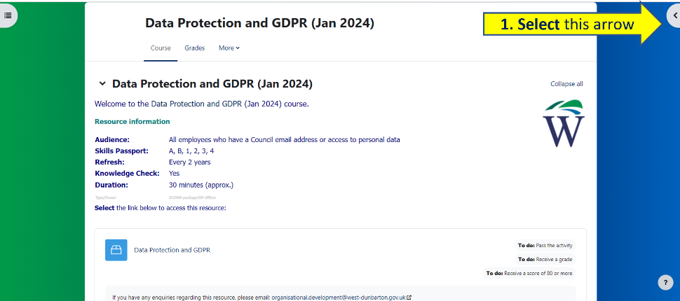

2. This will expand to show course completion status, then select more details

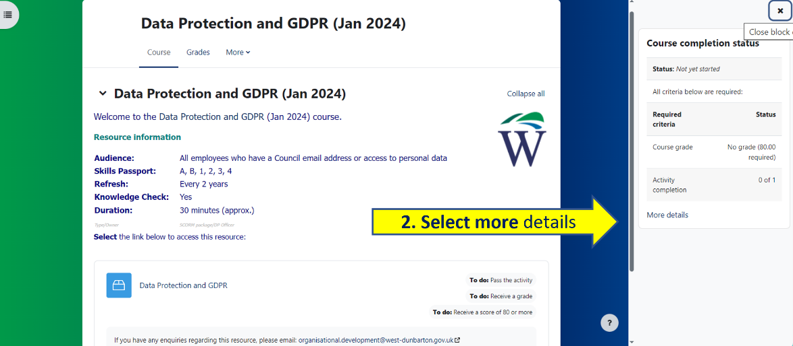

- Course progress details, including completion date, will display as follows:

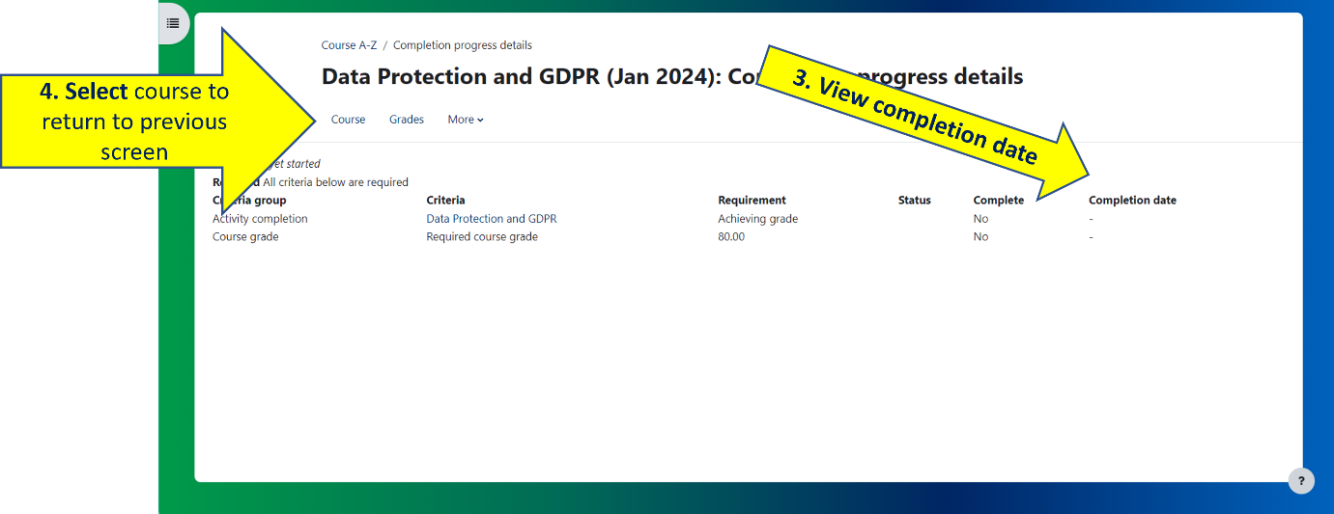

- Select course to return to the previous screen.

NEW: Mandatory learning - course re-completion reminder emails* (*only available for course enrolments made after 18/04/24)
Mandatory i-Learn courses are identified by the requirement to refresh your learning every 1, 2 or 3 years. Following WDC i-Learn platform upgrade on 19/04/24, and once you have completed each course on the updated platform, you will receive a reminder email advising it is time to re-complete the course (subject to having an up-to-date email address in WDC iLearn).
Re-completion email notification example:
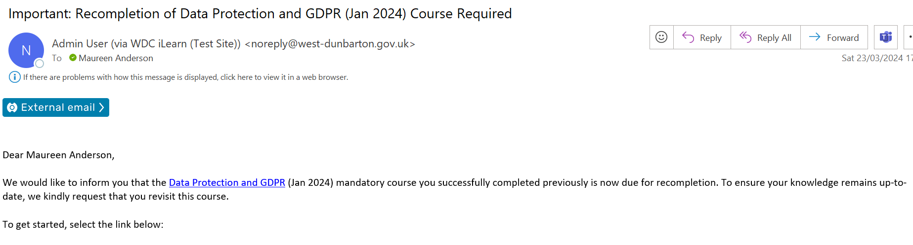

NOTE: Skills Passports provide full details of mandatory and recommended i-Learning requirements for all employees.
WDC mandatory i-Learn courses | Refresh | Skills Passport
 |  | A | B | 1 | 2 | 3 | 4
ACHIEVE – Living the Values | Y – 3 yrs | ü | ü | ü | ü | ü | ü
Adult Support and Protection – Basic Awareness (role specific) | Y – 3 yrs | ü | ü | ü | ü | ü | ü
Asbestos – The Hidden Killer (role specific) | Y – 2 yrs | ü | ü | ü | ü | ü | ü
Child Protection – Basic Awareness (role specific) | Y – 3 yrs | ü | ü | ü | ü | ü | ü
Data Protection Act 2018 and GDPR | Y – 2 yrs | ü | ü | ü | ü | ü | ü
Display Screen Equipment (DSE) Assessment | Y – 3 yrs | ü | ü | ü | ü | ü | ü
Equality Impact Assessment | Y – 3 yrs | ü |  | ü | ü | ü | ü
Equality, Diversity and Human Rights | Y – 3 yrs | ü | ü | ü | ü | ü | ü
Fire Safety (Including Wardens) | Y – 2 yrs | ü | ü | ü | ü | ü | ü
Fraud Awareness | Y – 2 yrs | ü | ü | ü | ü | ü | ü
Health and Safety Induction | Y – 3 yrs | ü | ü | ü | ü | ü | ü
Incident Reporting and Investigation | Y – 2 yrs | ü |  | ü | ü | ü | ü
Information Security | Y – 3 yrs | ü | ü | ü | ü | ü | ü
Ladder Safety Awareness | Y – 2 yrs | ü | ü | ü | ü | ü | ü
Managing Safety | Y – 3 yrs | ü |  | ü | ü | ü | ü
Manual Handling | Y – 3 yrs | ü | ü | ü | ü | ü | ü
Procurement Awareness | Y – 2 yrs | ü | ü | ü | ü | ü | ü
Responsible Premises Officer Guidance (RPO) (role specific) | Y – 2 yrs | ü |  | ü | ü | ü | ü
Risk Management | Y – 2 yrs | ü |  | ü | ü | ü | ü
Records Management | Y – 3 yrs | ü | ü | ü | ü | ü | ü
Sexual Harassment in the Workplace | Y – 3 yrs | ü | ü | ü | ü | ü | ü
Slips, Trips and Falls | Y – 3 yrs | ü | ü | ü | ü | ü | ü
Supporting Employee Wellbeing Policy | Y – 3 yrs | ü | ü | ü | ü | ü | ü
Trauma Informed Practice Basics module 1 | Y – 3 yrs | ü | ü | ü | ü | ü | ü
WDC Employee Guide to the Complaints Procedure | Y – 2 yrs | ü | ü | ü | ü | ü | ü
WDC Recruitment and Selection | Y – 3 yrs |  |  | ü | ü | ü | ü

If you require further support,
please email: organisational.development@west-dunbarton.gov.uk

